**File Details and Output generated:-**

1. **readtextfile.js file:-**In this file, I have created a Node.js to read text file and return the response in JSON. Code will then read the request URL and based on it, the response will be sent back.

Steps of Execution:-

1. on the command prompt:-

|  |
| --- |
| Node readtextfile.js  2. Open any browser and enter the following URL  <http://localhost:5050> |

1. **Generating Report: -** I have written the python file that generates the report.

**Output:-**

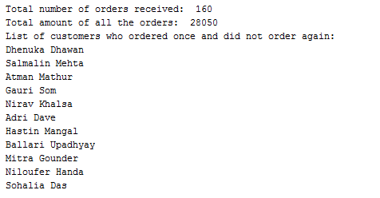

After generating the data, I have created HTML files with Python scripts, and use Python to automatically open an HTML file (“report.html”) in browser using webbrowser.

I have used plotly library to show graph in browser.

